James W. Sale
April 24, 1881 – September 14, 1931

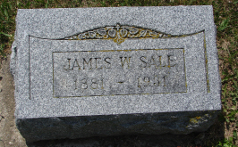
Photo by Sarge

James W Salo
in the Indiana, Death Certificates, 1899-2011
Name: James W Sale
Gender: Male
Race: White
Age: 51 years, 4 months, 20 days
Marital status: Married
Birth Date: abt 1880
Birth Place: North Carolina
Death Date: 14 Sep 1931
Death Place: Wells, Indiana, USA
Father: Willis Sale
Mother: Rufina Johnson
Informant: Verta Sale; Uniondale, Indiana
Burial: September 16, 1931; Spider Hill Cemetery

