Carol Rae Sale
December 25, 1934 – December 31, 1934

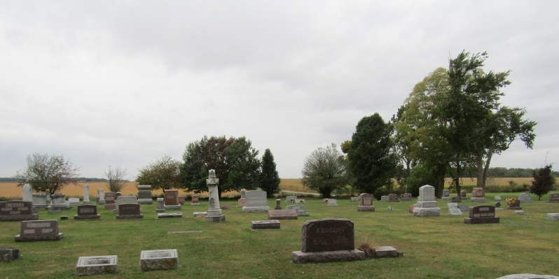

Carol Rae Sales
in the Indiana, Death Certificates, 1899-2011
Name: Carol Rae Sales
Gender: Female
Race: White
Age: 0
Marital status: Infant
Birth Date: 25 Dec 1934
Birth Place: Jonesboro, Ind.
Death Date: 31 Dec 1934
Death Place: Jonesboro, Grant, Indiana , USA
Father: Raymond Sales
Mother: Eva Deveney
Burial: January 2, 1935; Rockford Cemetery

