Sarah B. (Sparks) Redding
February 9, 1814 – January 19, 1873

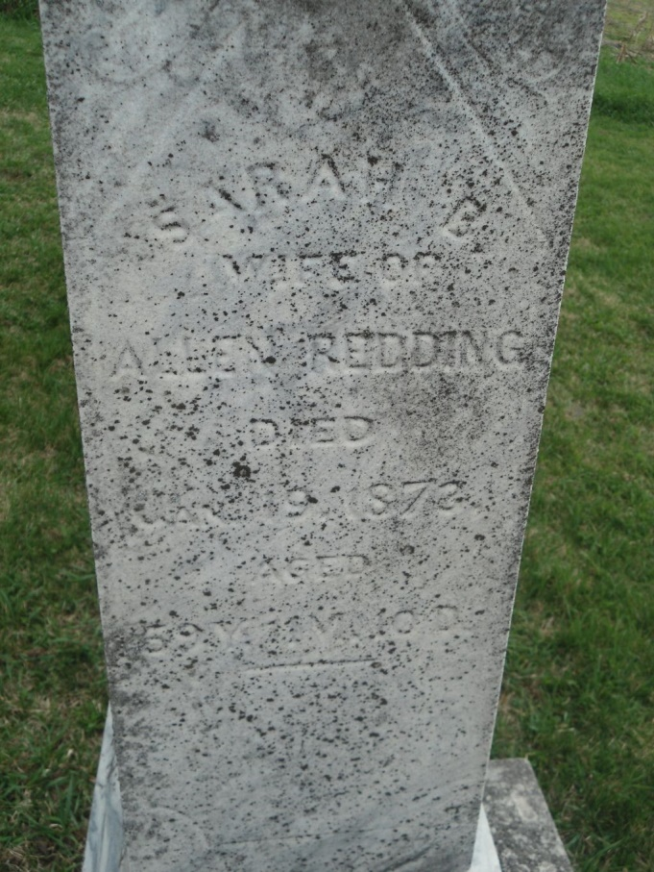
Photo by Steve

No further information found at this time

