Perry Emery Redding
January 1, 1867 – June 17, 1948

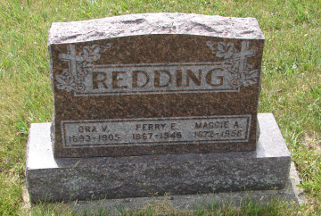
Photo by Sarge

Perry E. Redding, 81, known familiarly by friends as "Jacob", died at 10 a.m. Thursday at his home in Markle. He is reported to have been failing in health over a period of several years, but had not appeared in an immediately serious condition and his death was unexpected.
He had been a resident of Markle since 1895. His employment there included an association with a brother Thomas, in a grocery store for 21 years. He was a member of the I. O. O. F. Lodge at Brown Corners.
The decedent was born Jan. 1, 1867 in Rockcreek Township to Ransom and Miriam Highlen Redding. His marriage to Maggie Poff took place Nov. 18, 1890 in Bluffton.
Surviving are the wife, one daughter Mrs. Pearl Hite, near Huntington; one son, Eldon, of Huntington; 11 grandchildren; eight great-grandchildren and one brother, Amos Redding, of Bluffton. One son, Ora, a daughter, Mrs. Clella Horrell and infant daughter, four brothers and five sisters are deceased.
The body was removed to the McGuffey Funeral Home where services in charge of Rev. Richard Burton, of the Markle Church of Christ, will be held at 2:30 Saturday afternoon. Burial will be in the Methodist Cemetery, north of Rockford.

Bluffton News-Banner, Wells County, Indiana
June 18, 1948

