Luster S. Redding
October 8, 1864 – August 13, 1953

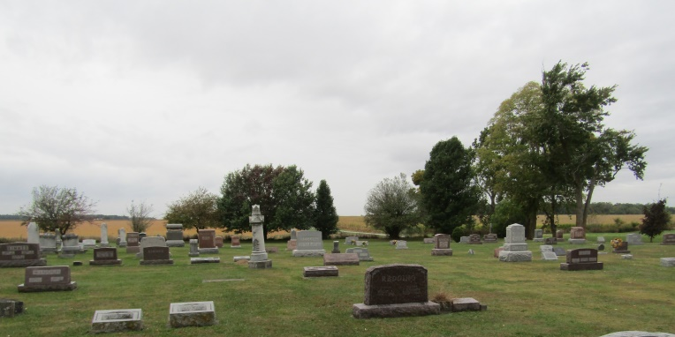

Luster Redding, 88, 110 West Cherry St., died at 2 o'clock this morning at the Wells County after an illness of six months. The decedent was born Oct. 8, 1865 in Rockford to Frank and Malinda Redding. His marriage to Florence Legg took place July 17, 1911 in Covington, Ky. He was a member of the Epworth Methodist Church.
Mrs. Redding is a patient at the Wells County Hospital.
A sister, Mrs. Anna Cobbum, is deceased.
The body was removed to the Thoma Funeral Home where friends may call. Funeral services will be held at 1:30 Saturday afternoon at the funeral home with Rev. E. N. Rosier officiating. Burial will be in the Rockford Methodist Cemetery.

Herald-Press, Huntington County, Indiana
August 13, 1953

*****
Luster Redding
in the Indiana, Death Certificates, 1899-2011
Name: Luster Redding
Gender: Male
Race: White
Age: 88
Marital status: Married
Birth Date: 8 Oct 1964
Birth Place: Wells Co, Indiana
Death Date: 13 Aug 1953
Death Place: Bluffton, Wells, Indiana , USA
Father: Irona Redding
Mother: Malinda
Informant: Mrs. Florence Redding; Bluffton, Indiana
Burial: August 15, 1953; Rockford Methodist Cemetery; Rockford, Indiana

