Thomas H. Pitzer
January 27, 1879 – July 29, 1958

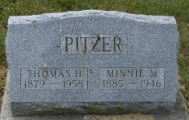
Photos by Smalltown

Thomas H. Pitzer
in the Indiana, Death Certificates, 1899-2011
Name: Thomas H. Pitzer
Gender: Male
Race: White
Age: 79
Marital status: Widowed
Birth Date: 27 Jan 1879
Birth Place: West Virginia
Death Date: 29 Jul 1958
Death Place: Bluffton, Wells, Indiana, USA
Father: Michael Pitzer
Mother: Betty Diddle
Informant: Mrs. Halcyon Redding; Bluffton, Indiana
Burial: July 31, 1958; Old Methodist Cemetery; Rockcreek, Indiana

