William Alfred Mullis
July 19, 1858 – April 13, 1933

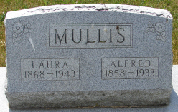
Photos by Smalltown

Alfred Mullies
in the Indiana, Death Certificates, 1899-2011
Name: Alfred Mullies
[Alfred Mullis ]
Gender: Male
Race: White
Age: 74
Marital status: Married
Birth Date: 19 Jul 1858
Birth Place: North Carolina
Death Date: 13 Apr 1933
Death Place: Rockford, Wells, Indiana, USA
Father: Wm Mullies
Mother: Rebecca Nicholson
Spouse: Laura
Informant: Mrs. Alfred Mullies; Rockford, Indiana
Burial: April 15, 1933; Spider Hill Cemetery

