Clarence D. Korn
December 13, 1887 – January 1, 1907

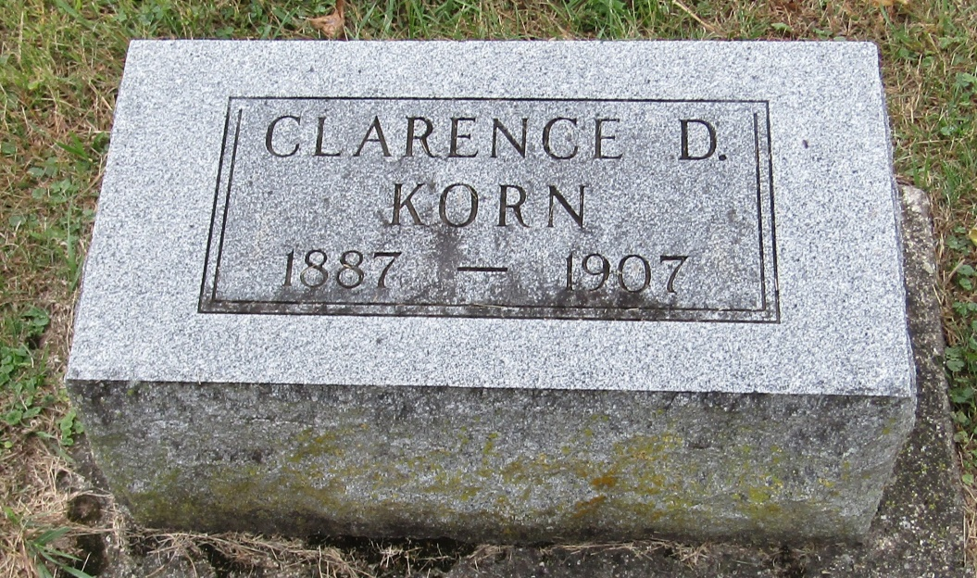

C D Korn
in the Indiana, Death Certificates, 1899-2011
Name: C D Korn
Gender: Male
Race: White
Age: 19
Marital status: Single
Birth Date: 13 Dec 1887
Birth Place: Wells Co
Death Date: 1 Jan 1907
Death Place: Rock Creek, Wells, Indiana, USA
Father: A J Korn
Mother: Nora Johnson
Informant: A. J. Korn; Bluffton, Indiana
Burial: January 3, 1907; Spider Hill Cemetery

