Andrew Jackson Hawkins

June 12, 1859 – December 18, 1936

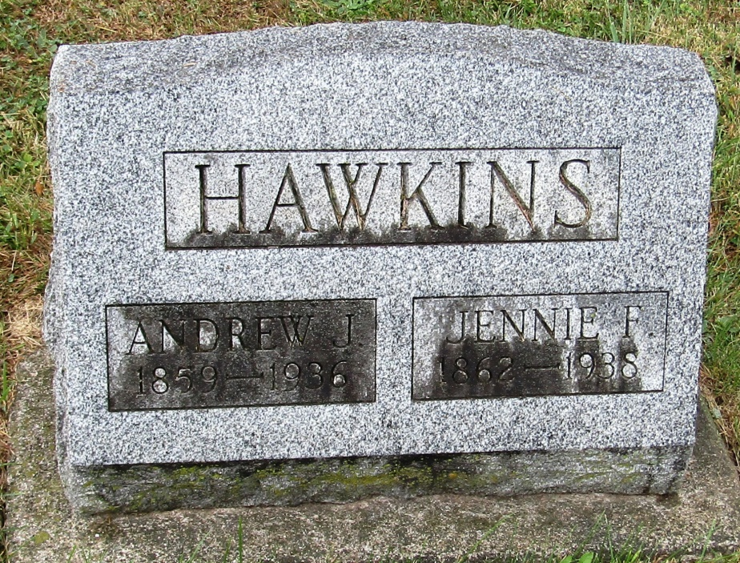

Andrew Jackson Hawkins from tree Jay-Curley-Nolf-McCoy-Weeks-McDowell Family Trees  
Record information.  
Birth 12 Jun 1859 Monroe, West Virginia, USA  
Marriage 25 Feb 1885 Monroe, West Virginia, USA  
Residence 2 Apr 1930 Canton, Stark, Ohio, USA  
Death 18 Dec 1936 Indiana, USA  
Record information.  
Father Archibald McDowell Hawkins (1814-1876)  
Mother Isabella Miller (1830-1902)  
Spouse Jennie F. Thacker (1862-1938)