Hazel Haughton
August 17, 1897 – June 13, 1985

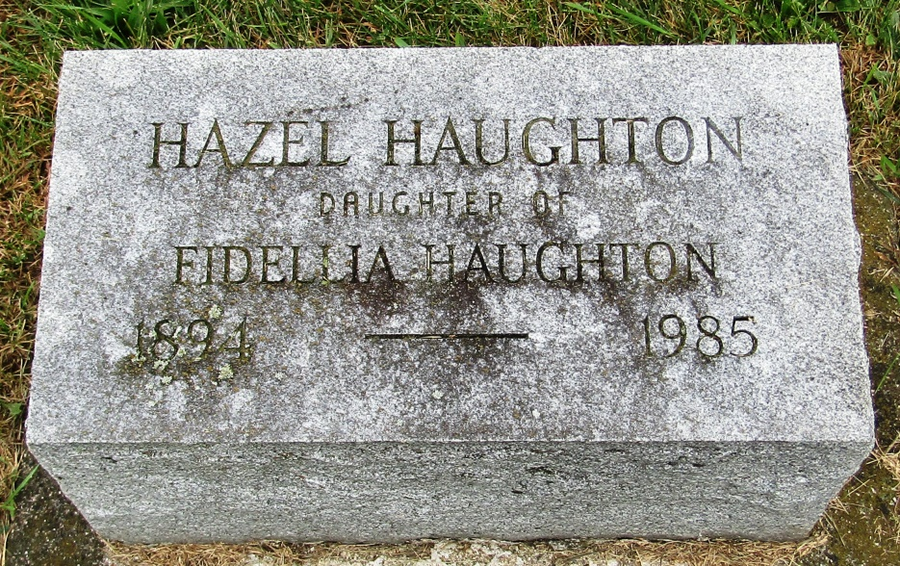

Hazel Haughton
in the Indiana, Death Certificates, 1899-2011
Name: Hazel Haughton
Gender: Male
Race: White
Age: 88
Marital status: Never Married (Single)
Birth Date: 17 Aug 1897
Birth Place: Indiana
Death Date: 13 Jun 1985
Death Place: Bluffton, Wells, Indiana, USA
Father: Francis Haughton
Mother: Fidellia Carey
Informant: Paul E. Johnson; nephew; Berne, Indiana
Burial: June 15, 1985; Rockford Methodist Cemetery; Wells County, Indiana

