Ores Franklin Freds
March 21, 1890 – June 9, 1955

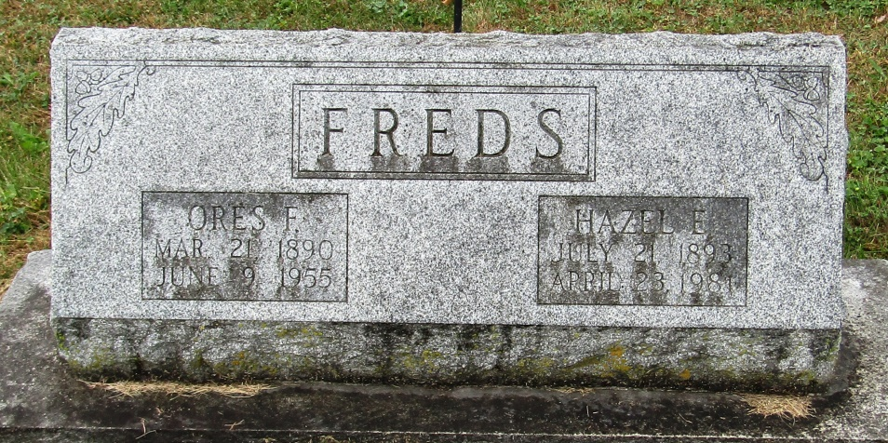

Pres Franklin Freds
in the Indiana, Death Certificates, 1899-2011
Name: Ores Franklin Freds
Gender: Male
Race: Caucasian (White)
Age: 65
Marital status: Married
Birth Date: 21 Mar 1890
Birth Place: Huntington Co, Ind
Death Date: 9 Jun 1955
Death Place: Bluffton, Wells, Indiana, USA
Father: Charles Freds
Mother: Elmira Hoag
Informant: Mrs. Hazel Freds; Bluffton, Indiana
Burial: June 11, 1955; Methodist Cemetery; Rockford, Indiana

