Cynthia Ann (Mullies) Fishbaugh-Victor
1871 - 1944

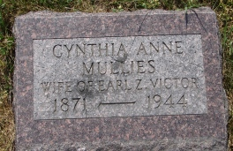

No further information found at this time

