Thurman Willard Earhart
August 14, 1888 – February 5, 1966

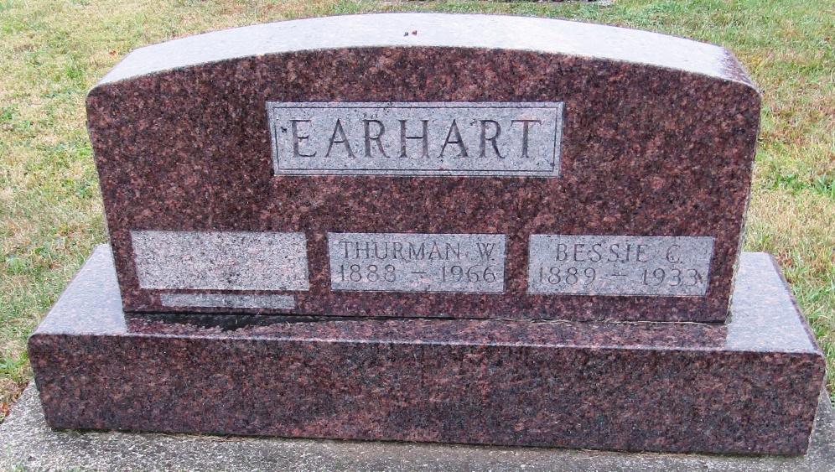

Thurman W Earhart
in the Indiana, Death Certificates, 1899-2011
Name: Thurman W Earhart
Gender: Male
Race: White
Age: 77
Marital status: Married
Birth Date: 14 Aug 1888
Birth Place: Wells County, Indiana
Death Date: 5 Feb 1966
Death Place: Ft Wayne, Allen, Indiana, USA
Father: Jacob Earhart
Mother: Lydia Katherine Jarvis
Informant: Opal Earhart; wife; Fort Wayne, Indiana
Burial: February 7, 1966; Rockford Cemetery; Wells County, Indiana

