Arthur Jacob Earhart
September 16, 1910 – May 23, 1943

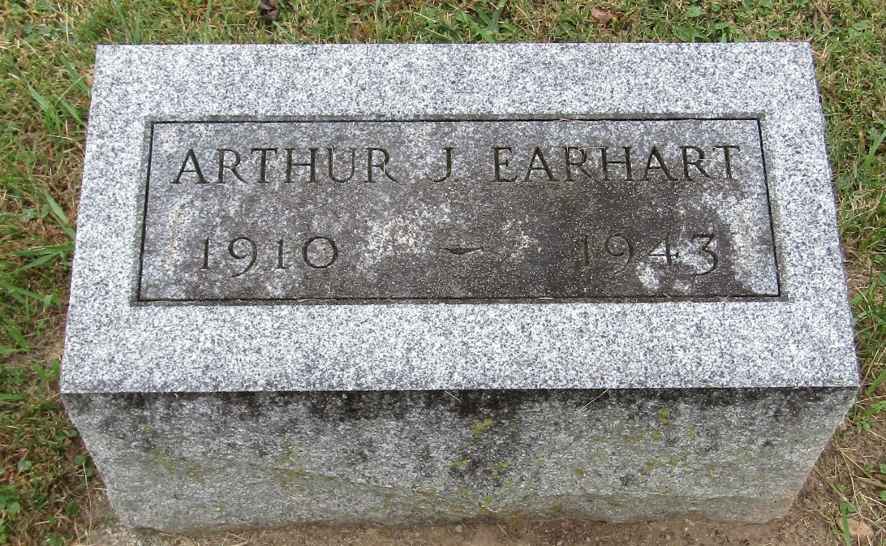

Arthur Jacob Earhart
in the Indiana, Death Certificates, 1899-2011
Name: Arthur Jacob Earhart
Gender: Male
Race: White
Age: 32
Marital status: Married
Birth Date: 16 Sep 1910
Birth Place: Rockcreek Wells Co
Death Date: 23 May 1943
Death Place: Rural, Wells, Indiana, USA
Father: Shurman Earhart
Mother: Bessie Redding
Spouse: Anna Hesher
Informant: Mrs. Arthur Earhart; Bluffton, Indiana
Burial: May 25, 1943; Rockford M. E. Cemetery; Rockford, Indiana

