William Crosbie
September 2, 1887 – January 9, 1943

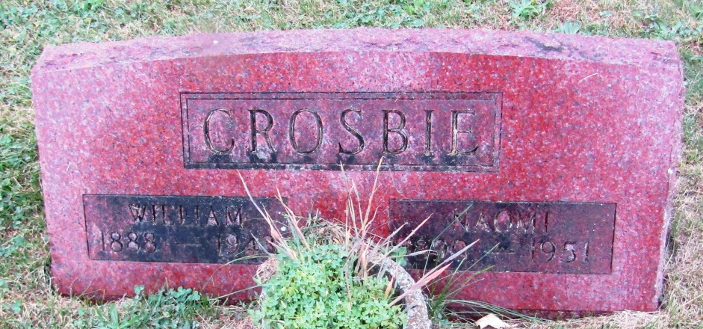

William Crosbie
in the Indiana, Death Certificates, 1899-2011
Name: William Crosbie
Gender: Male
Race: White
Age: 55
Marital status: Married
Birth Date: 2 Sep 1887
Birth Place: Indiana
Death Date: 9 Jan 1943
Death Place: Huntington, Huntington, Indiana, USA
Father: Thomas Crosbie
Mother: Mary Cupp
Spouse: Naomi
Informant: Lester Crosbie; Markle, Indiana
Burial: January 12, 1943; Methodist Cemetery; Rockford, Indiana

