Naomi (Wilburn) Crosbie
May 15, 1890 – April 26, 1951

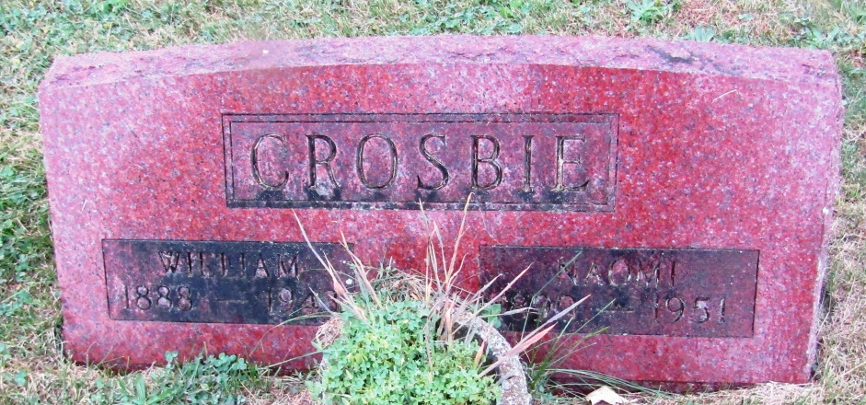
Mrs. Naomi Crosbie Claimed by Death
Funeral Services are Set for Saturday Afternoon
Mrs. Naomi Crosbie, 60, a lifelong resident of Markle, died at the Wells County Hospital at 11:25 a.m. Thursday. Mrs. Crosbie was born May 15, 1890, to George and Mary Jane Decker Wilburn, in Huntington County south of Markle. She was married to William Crosbie in 1909. Mr. Crosbie died January 9, 1943.
Surviving are a son, Lester, Markle; three brothers, Roy Wilburn, Huntington, Oscar Wilburn, Rockford and Raymond Wilburn, Ossian; three sisters, Mrs. Rena Babcock, Rockford, Mrs. Julia Gordon, Bluffton, and Miss Iva Wilburn, Rockford; and two grandchildren, Carolyn Sue and Karen Lou Crosbie. A son, Leslie, and two daughters preceded her in death.
The body was removed to the McGuffey Funeral Home, Markle, where friends may call. Funeral Services will be held at 2 p.m. Saturday at the Markle Methodist Church, of which she was a member, with the Rev. A.R. Sanks officiating. Burial will be in the Methodist Cemetery, Rockford.

Unknown source

*****
Indiana, Death Certificates, 1899-2011
Name: Naomi Wilburn Crosbie
Gender: Female
Race: White
Age: 60
Marital status: Widowed
Birth Date: 15 May 1890
Birth Place: Huntington Co Indiana
Death Date: 26 Apr 1951
Death Place: Bluffton, Wells, Indiana, USA
Father: George Willburn
Mother: Mary Jane Decker
Informant: Lester Crosbie; Markle, Indiana
Burial: April 28, 1951; Methodist Cemetery; s/o Markle, Indiana

