Orie M. Creek
May 15, 1885 – May 30, 1941

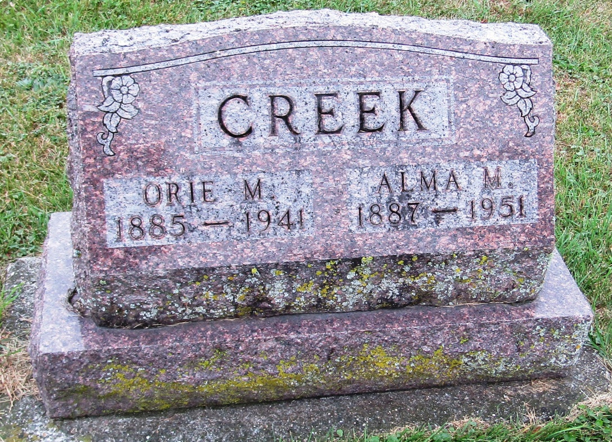

Orie M. Creek Is Claimed By Death
Rockcreek Farmer Dies Early Friday And Funeral To Be Sunday
Orie M. Creek, 56, died at 1:30 a.m. Friday at his home in Rockcreek Township of bronchial asthma and complications, following a period of illness. Born in Blackford County, the decedent was a son of Mr. and Mrs. Jasper Creek. He and his family moved to Wells County 13 years ago and have resided near Rockford since.
Surviving are the widow; two sons, Harold, of Van Buren, and Everett, of Bluffton; and four daughters, Mrs. Norval Kline of Bluffton; Mrs. Lloyd Schriner, of Huntington, and Leona and Elma Creek, at home.
Funeral services will be held at 2 p.m. Sunday at the Emanuel Methodist Church and burial will be in the Methodist Cemetery at Rockford.

Evening News Banner, Wells County, Indiana
Saturday, May 31, 1941
*****
Orie M Creek
in the Indiana, Death Certificates, 1899-2011
Name: Orie M Creek
Gender: Male
Race: White
Age: 56
Marital status: Widowed
Birth Date: 15 May 1885
Birth Place: Blackford Co Ind
Death Date: 30 May 1941
Death Place: Rural, Wells, Indiana, USA
Father: Jasper Creek
Mother: Marienna Roberts
Spouse: Alma Carnes; aged 52 years
Informant: Mrs. O. M. Creek; Bluffton, Indiana
Burial: June ??; Methodist Cemetery; Rockford, Indiana

