Jacob Connett

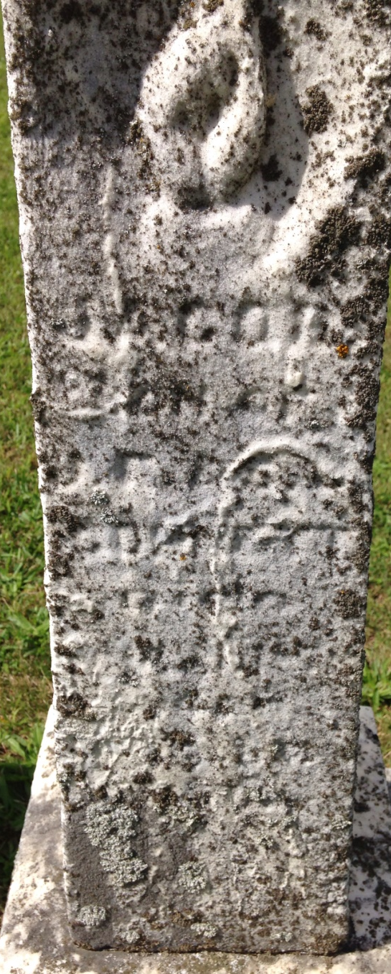
Photo by Barbara Baker Anderson

No further information found at this time

