Harriett Isabelle (Naylor) Brown
August 23, 1846 – June 5, 1925

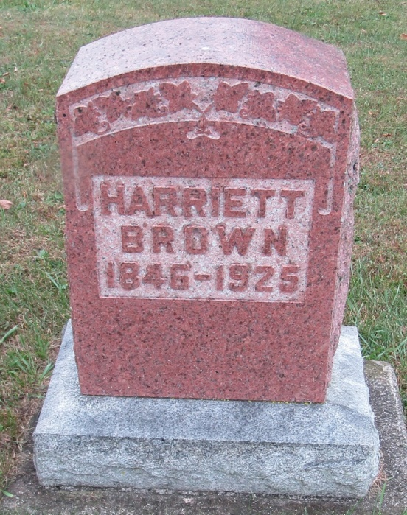

Henrietta J. Brown
in the Indiana, Death Certificates, 1899-2011
Name: Harriette J. Brown
[Henrietta J. Naylor]
Gender: Female
Race: White
Age: 78
Marital status: Widowed
Birth Date: 23 Aug 1846
Birth Place: N. C.
Death Date: 5 Jun 1925
Death Place: Fairmount, Grant, Indiana, USA
Father: John Naylor
Informant: Ottis Mibern?; Fairmount, Indiana
Burial: June 7, 1925; Rockford, Indiana

