Thomas Jesse Boyer
May 7, 1893 – April 11, 1925

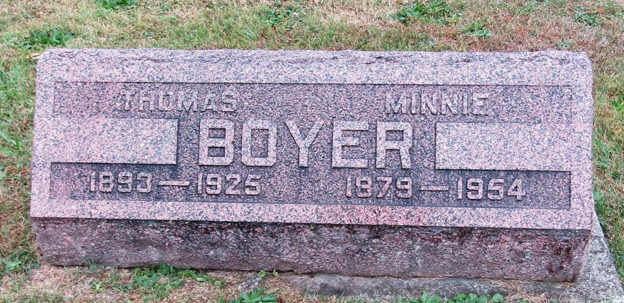

Thomas Jesse Boyer
in the Indiana, Death Certificates, 1899-2011
Name: Thomas Jesse Boyer
Gender: Male
Race: White
Age: 31
Marital status: Married
Birth Date: 7 May 1893
Birth Place: Wells Co., Indiana
Death Date: 11 Apr 1925
Death Place: Indianapolis, Marion, Indiana , USA
Father: George S. Boyer
Mother: Mercy Anne Holcomb
Spouse: Minnie
Informant: Minnie Boyer: Huntington, Indiana
Burial: April 16, 1925: Huntington, Indiana

