Morris Joseph Anderson Boyer
December 4, 1877 – January 15, 1917

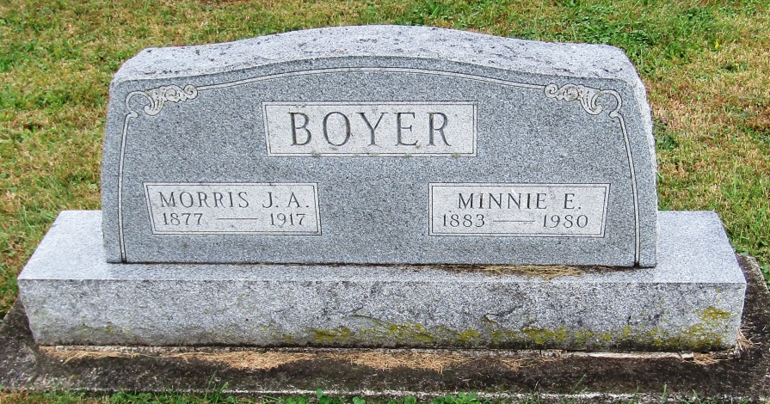

Morris Boyer
in the Indiana, Death Certificates, 1899-2011
Name: Morris Boyer
Gender: Male
Race: White
Age: 39
Marital status: Married
Birth Date: 4 Dec 1877
Birth Place: Indiana
Death Date: 15 Jan 1917
Death Place: Huntington, Indiana, USA
Father: Demas Boyer
Mother: Almeda Wilburn
Spouse: Minnie Boyer
Informant: Minnie Boyer; Warren, Indiana
Burial: January 17, 1917; Rockford M. E. Cemetery

