John Joseph Boyer
1805 - 1877

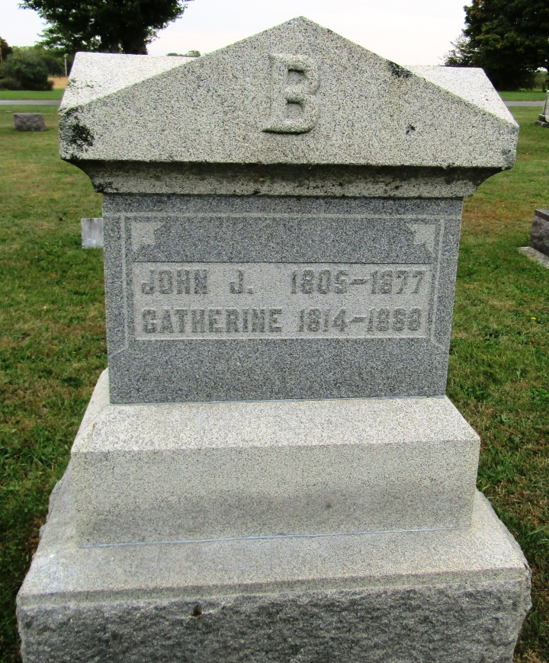

No further information found at this time

