Catherine (Seidsinger) Boyer
1814 - 1888

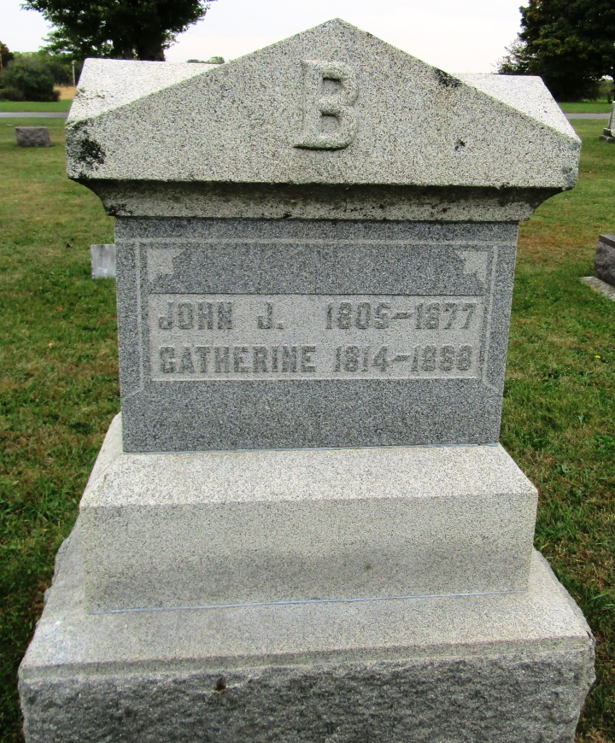

No further information found at this time

