Clellah May (McAfee) Bennett
December 25, 1875 – August 27, 1900

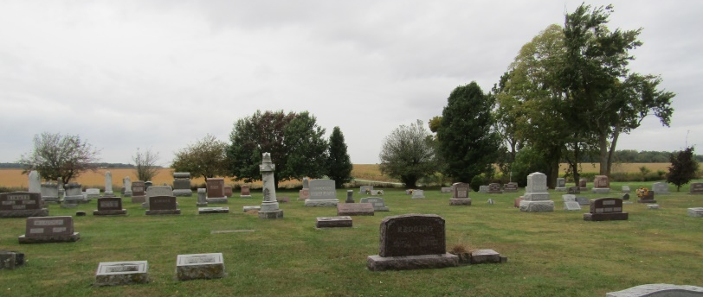

Clella May Mc Affee
in the Indiana, Death Certificates, 1899-2011
Name: Clella May Bennett
Maiden Name: McAffee
Gender: Female
Race: White
Age: 24 years, 8 months, 2 days
Marital status: Widow
Birth Date: abt 1876
Birth Place: Indiana
Death Date: 27 Aug 1900; TB
Death Place: Bluffton, Wells, Indiana , USA
Father: James M Mc Affee
Mother: Arminda Redding
Informant: Fred McBride; Bluffton, Indiana
Burial: August 29, 1900; Rockford, Indiana

