John Julius Armstrong
May 12, 1863 – May 26, 1916

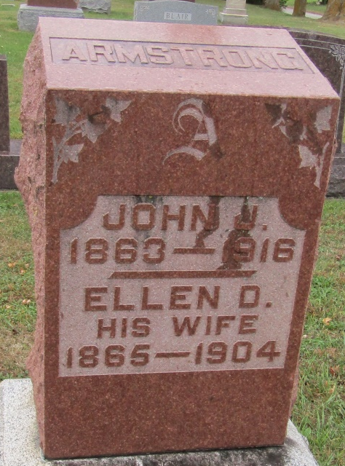

John Juhas Armstrong
in the Indiana, Death Certificates, 1899-2011
Name: John Julias Armstrong
Gender: Male
Race: White
Age: 53
Marital status: Widow
Birth Date: 12 May 1863
Birth Place: Spoon Creek, N.C.
Death Date: 26 May 1916
Death Place: Union, Wells, Indiana , USA
Father: Armstrong
Mother: Mary
Informant: Oren Johnson; Bluffton, Indiana
Burial: May 28, 1916; M. E. Cemetery; Rockford

