Isaac B. Sparks
May 12, 1812 – January 15, 1904

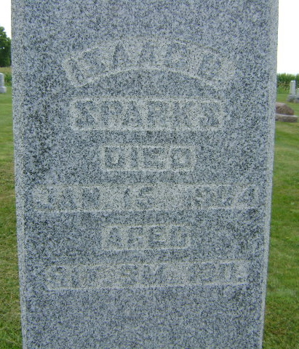

Isaac Sparks, an old and well known resident of this part of the county, died Friday evening at the home of his son-in-law, Frank Hart, a mile south of Pleasant Plain in Jefferson Township. His death was caused by pneumonia from which he had been suffering for several weeks. The deceased was nearly ninety-two years old.
When about eighteen years old he came with his parents to Huntington County and settled in Rock Creek Township. In 1851 he was married to Cyntha Ann Roberts; twelve children were born to the couple. Four sons and four daughters are still living.
Mrs. Sparks died a number of years ago and Mr. Sparks has lived with his children since her death.
The funeral was held from the Christian church at Plum Tree last Sunday, and the burial was in the Sparks Cemetery.

Unknown source

