Mary Estella (Bonham) Redding
November 14, 1868 – November 7, 1942

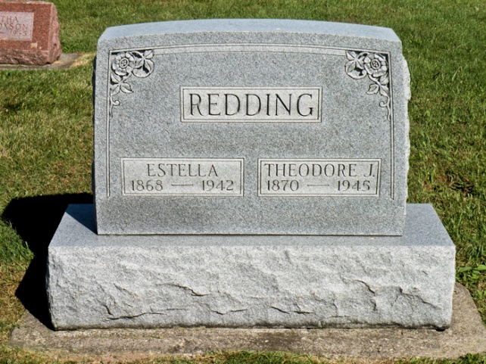

Mrs. Mary Estella Redding, 73, was found dead in bed at 1 a.m. this morning at her home three-quarters of a mile west of Rockford, following an illness of one week.
Mrs. Redding was born in Huntington County, Nov. 14, 1858, to Cary W. and Sarah Brown Bonham. She was married in Warren, on Nov. 1, 1890, to Theodore J. Redding, who survives.
Surviving besides the husband are a son, Stanley Redding, of Bluffton, route 1; two sisters, Mrs. Samuel Colbert, of Huntington; Mrs. Ernest Prible, of Preble, and a brother, Asa Bonham, of Warren.
Funeral services will be held at 2 p.m. Monday at the Old Buckeye church of which Mrs. Redding was a member in charge of Rev. Wilbur Sullivan of Roann. Burial will be in the Sparks Cemetery.
Friends are asked to please omit flowers.

Bluffton News Banner, Wells County, IN; November 7, 1942

