Dr. John Leslie Redding
October 23, 1876 – September 29, 1948

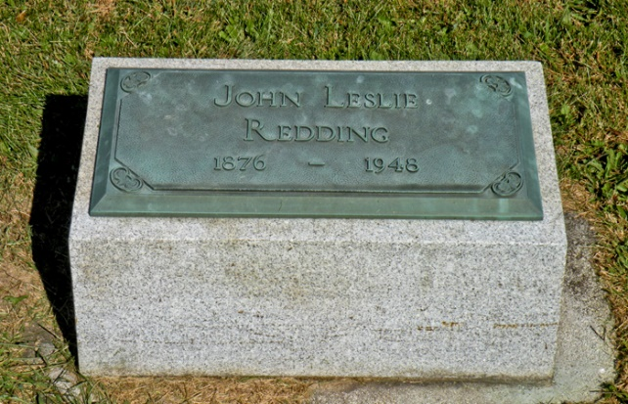

A message received here today told of the death of Dr. J. L. Redding, 71, a former Bluffton physician, who died at 4 o'clock this morning at his home in Orlando, Fla. Funeral services will be conducted at 2 p.m. Friday at Orlando.
Dr. Redding had been in a condition of failing health for more than two years, due to injuries received in a traffic accident.
He was a native of Salamonie Township, Huntington County, and was a son of the late Mr. and Mrs. Rufus Redding. He located in Bluffton in 1919 in the practice of medicine, having been associated with the late Dr. Fred Metts. He and his family moved to Florida about 20 years ago.
His marriage was to Anna Roberts, a daughter of the late Mr. and Mrs. John Roberts, of Rock Creek Township. Her death occurred June 3, this year.
Surviving are two sons, Raymond and Robert, both of Florida; two brothers, Linden, of Marion, and Marion, of Texas, and two sisters, Mrs. Cora Brown, of Warren, and Mrs. Olive Crofut, of Detroit.

Bluffton News Banner, Wells County, IN; September 29, 1948

