William Kellam Lantis
February 27, 1866 – October 15, 1953

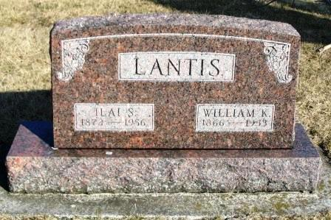
Photo by Barbara Baker Anderson

William Kellam Lantis, 87, retired farmer of Rock Creek Township, died Thursday at his home after an illness of two years of complications. Mr. Lantis was born in Preble County, Ohio, to Dan Perry and Nancy Flora Lantis on February 27, 1866. He came to Huntington when 10 Years of age and had lived in the community ever since. He married Ilai Brickley at Markle on June 7, 1891.
Surviving are the widow, one son, Orva Lantis at home, two grandchildren 3 great-grandchildren, two brothers, Oscar Lantis, Montpelier; and David Lantis, Galesburg, Mich., and a sister, Mrs. Mary Hoover, Huntington, Route 4. A brother and a sister are dead.
Mr. Lantis was a member of the Methodist Church at Rockford. The body is at the H. Brown and Son Funeral Home at Warren where friends may call Friday and where funeral services will be held Saturday with the Rev. Harold B. Bahert, pastor of the Methodist Church at Warren, officiating. Burial will be in the Sparks Cemetery, Wells County.
Music furnished by Mrs. Nora Huffman, vocalist and Mrs. L W Smith, pianist. Pallbearers: Paul Johnson, Joe Lieurance, Junior Ralston, Freeman Bockman, Okal McCracken and Roy Ogle.

Herald-Press, Huntington, IN; October, 16, 1953

