Clara Elsie (Stephens) Lantis
July 19, 1884 – June 30, 1947

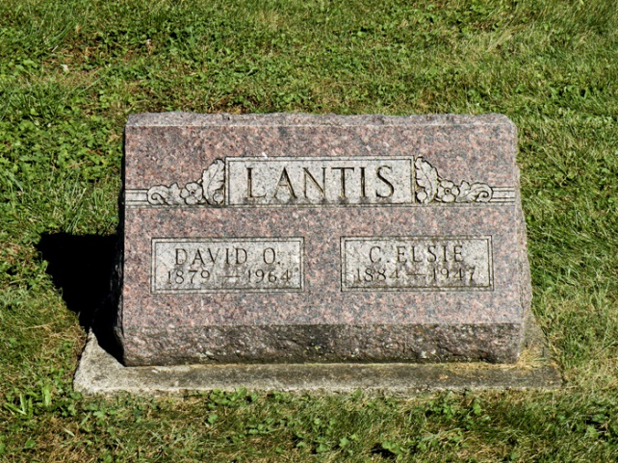

Mrs. Clara Elsie Lantis, 62, former resident of Huntington County, died Monday at her home in Galesburg, Mich., after a serious illness of 2 weeks. She had been ailing for five months and cause of death was complications.
She was born Jul 19, 1884, to Mr. and Mrs. Solomon Stephens. She married David O. Lantis Oct 15, 1904 in Huntington County.
Surviving are the husband; three sons, Orzo Dale Lantis, Detroit, Mich., Dolphus Perry Lantis, Galesburg, Mich., and David Arthur Lantis, Kalamazoo, Mich.; a daughter, Mrs. Bess Jennette Brundage, Kalamazoo, Mich.; two brothers, Smith Stephens of near Markle, and Nate Stephens of Warren, a sister, Phoebe Bradburn of south of Markle, and 12 grandchildren.
The family left this county 26 years ago for residence in Michigan. She was a member of the Markle Brethren church.
Funeral services will be held Wednesday at the Wilson funeral home in Galesburg. The body will be shipped to Markle and will arrive early Thursday morning and be taken to the Funderburg Funeral Home where friends may call and where services will be held at 2pm Thursday.
Burial will be in the Sparks Cemetery, south of Markle.

Herald-Press, Huntington, IN; July 1, 1947

