Anita C. Lantis
January 1, 1921 – January 1, 2006

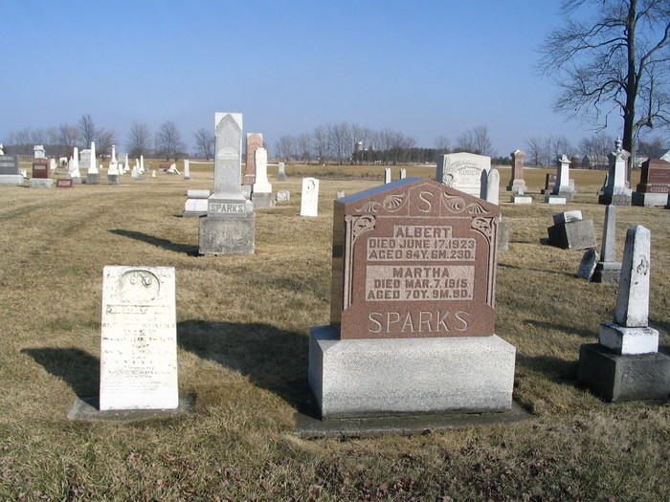

Anita C Lantis, 83, of Fort Wayne and formerly of Warren, IN died at 4:55 am Sunday, Jan 1, 2006 at Parkview Hospital, Fort Wayne. Miss Lantis was born Jan 1, 1921, daughter of Orva V and Mary G. "Goldie" Newman Lantis.
Survivors include four nieces. A brother, Adrian Lantis, preceded her in death.
Graveside services will be held at 10 am Friday at the Sparks Cemetery, Wells County, with Rev John Backes officiating.

Herald-Press, Huntington, IN; January 3, 2006

