Ella (Grant) Heckman
February 6, 1857 – July 20, 1933

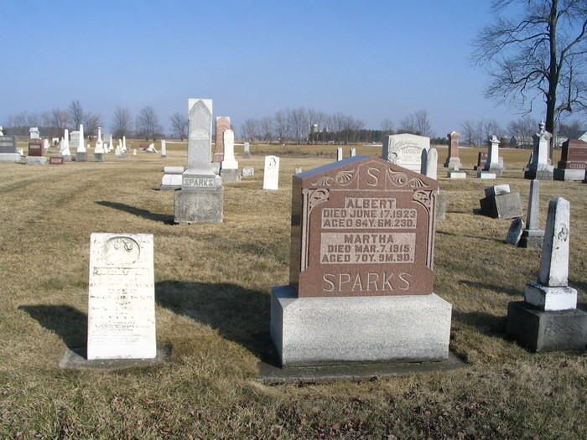
Photo by Barbara Baker Anderson

MARKLE - Aug 20 - (Special) – Mrs. Ella Heckman, 77, died at 1 o'clock this morning at her home here following an illness of gall trouble.
She was born to Jackson and Matilda Grant in Wells County, on February 6, 1857. Her first marriage was to William Wert. Two sons were born to this union. The husband and both sons are dead.
Her second marriage was to Andrew Heckman. Two daughters, Miss Lula Heckman at home and Mrs. Gertrude Wyatt of Rock Creek and two grandchildren survive.
She was a member of the Evangelical church where funeral services will be held at 2:30 o'clock Tuesday afternoon with the Rev. Clyde Walter in charge. Burial will be at the Sparks Cemetery.

Unknown source

