John T. Connet
August 7, 1874 – December 11, 1904

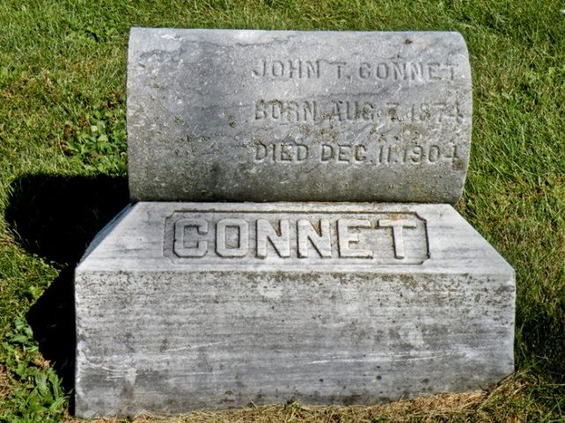

DEATH AT HOSPITAL
John T. Connet Succumbs to Bright’s Disease
Funeral at White Church Tuesday Morning – Had Recently Undergone an Operation

John T. Connet died Sunday morning about 6 o’clock at the Huntington Hospital as a result of Bright’s Disease. Mr. Connet resided about two miles north of Markle on a farm and was brought to the hospital about two weeks ago when he was operated upon for hemorrhoids by Dr. Charles Wright and got along nicely after the operation. He returned to his home a week ago today and soon of compelled to return to the hospital to receive treatment for Bright’s Disease. In spite of the physician’s efforts and best care of a nurse until death came to his relief Sunday.
He leaves a wife and four children to mourn his death. He was about thirty-five years old.
The remains were removed to Markle by the undertaker from that place about noon Sunday. Funeral services will be held at the White Church Tuesday forenoon. Interment will be in the cemetery nearby.

Unknown source

