Emojean (Jacob) Brumbaugh
June 1, 1928 – October 21, 2004

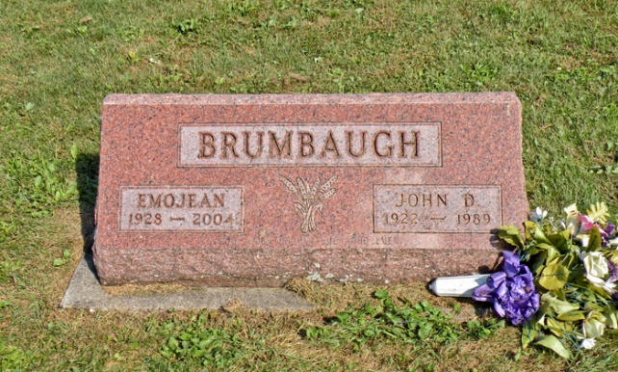

MARKLE – Emojean Brumbaugh, 76, United Methodist Memorial Home, died Thursday in Bluffton Regional Medical Center. The Ohio native, formerly of Markle was a retired registered nurse.
Survivors include daughters, Mindy Taylor, Vera Cruz, and Joan Richardson, Markle; and three grandsons.
Services are at 2 p.m. Saturday in Myers Funeral Home, 415 N. Lee St., Markle. Interment: Sparks Cemetery, Wells County. Visitation is from noon until services Saturday at the funeral home.
Memorials may be made to Markle Church of the Brethren, in care of the funeral home.

Unknown source

