David F. Thomas
July 7, 1816 – May 8, 1903

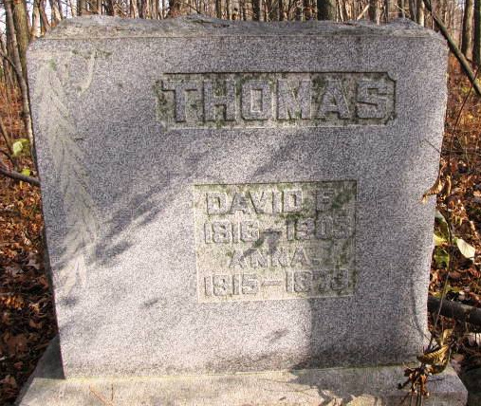
Photo by Barbara Baker Anderson

OLD CITIZEN DEAD
Saturday night at his home in Union Township, occurred the death of David F. Thomas, one of the pioneer residents of Wells County. He was a man far advanced in years, being in his eighty-sixth year. He came to Wells County in the earlier days and during his lifetime he has resided in Union Township where he died. For some time he has been in failing health and his demise was not wholly unexpected.
Mr. Thomas was an uncle to Miss Ida Thomas of this city and to Mrs. Sam Karns. He will be remembered by many of the older citizens of the county but in recent years he has not been about a great deal.
The funeral services occurred Sunday afternoon at two o'clock with interment in the Macedonia Cemetery in the edge of Huntington County. Members of the family from this city were in attendance at the funeral.

Bluffton Banner, Wells County, Indiana
Wednesday, May 13, 1903
*****
Indiana, Death Certificates, 1899-2011
Name: David Thomas
Gender: Male
Race: White
Age: 86
Marital Status: Married
Birth Date: 7 Jul 1816
Birth Place: Ohio
Death Date: 8 May 1903
Death Place: Union, Wells, Indiana, USA
Father: John A Thomas
Mother: Unknown
Spouse: Mary Jane Thomas
Burial: May 10, 1903 Callwyn (??) Cem.

