James Newton Shadle
October 26, 1864 – July 30, 1933

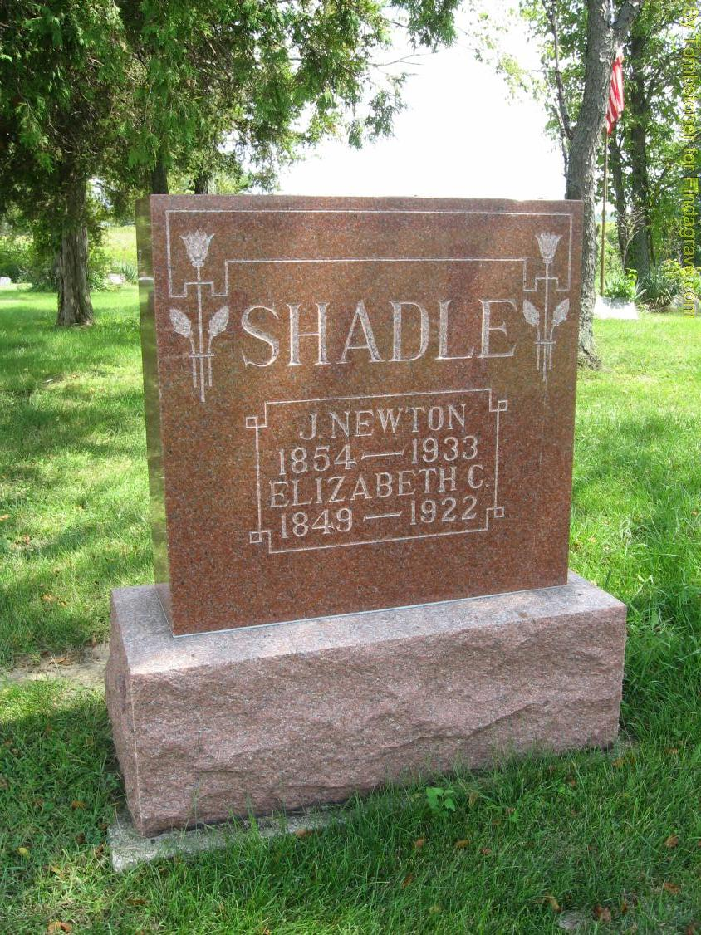
Photo by Tombstoner & Family
J. Newton Shadle Dies In Chester
Death Sunday Follows Long Illness And Funeral To Be Held Tuesday
J. Newton Shadle, 78, lifelong resident of Chester township, passed away at 7 o'clock Sunday morning at the home of a daughter, Mrs. John Osborn, in Chester township, following an illness for several years from infirmities of his advance age.
Born on Oct. 26, 1854, the deceased was a son of Philip and Margaret Donnely Shadle. His marriage to Miss Caroline Penrod took place on Feb. 12, 1875. Her death occurred on Jan. 6, 1922.
Surviving are three children, Oscar Shadle, and Mrs. John Osborn, Chester township, and Mrs. Lester Clark, Liberty township. Brothers and sisters are W. A. Shadle, Reason A. Shadle, Eli Shadle and Mrs. Frank Starr, all of Chester township.
Mr. Shadle was a member of the South Liberty Christian church.
Funeral services will be held at the home of the daughter and son-in-law, Mr. and Mrs. John Osborn, at 2 o'clock Tuesday afternoon, in charge of Rev. Lester Howell, Cowan. Burial will be in the Snow cemetery.

Evening News Banner, Wells County, IN; Monday, July 31, 1933 – P1C2
Contributed by David Huffman

