Elwin S. VanEmon
April 18, 1935 – December 22, 2014

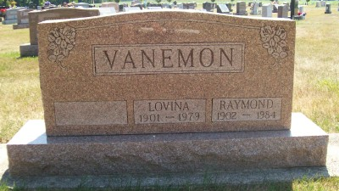
Photo by Scott Shoup

Elwin S. VanEmon, 79, of Fort Wayne, IN, passed away at 9:15 AM on Monday, December 22, 2014 at Lutheran Life Villages in Fort Wayne, IN, where he had resided for the past 13 years. He was born on Thursday, April 18, 1935, in Wells County, IN, to Raymond and Lovina VanEmon.
Elwin attended Geneva High School where he graduated with the class of 1954. He had lived with his parents locally in the Geneva area until their passing. Elwin was a member of the Geneva United Methodist Church. He was retired having been a driver for Amish construction crews locally. In his spare time, Elwin was an avid South Adams Starfires fan, and Geneva Cardinals enthusiast.
He is survived by his brother - Kenneth (wife, Eula) VanEmon, of Berne, IN., sister - Janice (husband, Jim) Hubert, Saint Louis, MO., 19 nieces and nephews, and numerous great-nieces and nephews.
He was preceded in death by his parents – Raymond & Lovina VanEmon, sister & brother in law - Theora & Ronald Elberson, and sister & brother in law - Jane & Roy Sordelet.
Family and friends may gather to share and remember at Lutheran Life Villages, 6701 S. Anthony Blvd., Fort Wayne, IN., on Monday, December 29, 2014 from 2:00 PM to 3:00 PM. A service to celebrate Elwin’s life will be at Lutheran Life Villages, 6701 S. Anthony Blvd., Fort Wayne, IN., on Monday, December 29, 2014 at 3:00 PM with the Rev. Mike Wakeland officiating. Interment will follow in the Six Mile Cemetery in Bluffton.

Downing & Glancy Funeral Home, Adams County, Indiana
December 26, 2014

