Lonny D. Reynolds
March 8, 1963 – November 11, 1993

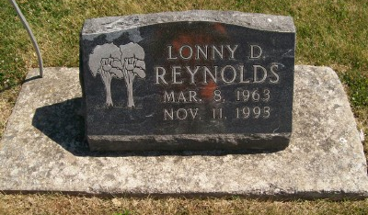
Photo by Scott Shoup
Funeral rites will be Saturday for Lonny D. Reynolds, 30, of 910 Mobile, Bluffton, who died at 7:22 p.m. Thursday at Parkview Memorial Hospital. Born March 8, 1963, in Decatur, he was a son of Robert D. Reynolds and Betty R. Neuenschwander Mann. He was employed at Energy Control, Ossian.
Surviving, in addition to the parents, are a sister Laurie Gardner of Markle; a half-brother, Shawn L. Mann of Bluffton; and his paternal grandmother, Cathleen Reynolds of Bluffton.
Friends may call after 6 p.m. today at Goodwin Memorial Chapel. Rites will be officiated by Rev. Robert Cahoon at 2 p.m. Saturday at Goodwin Memorial Chapel. Burial will take place in Six Mile Cemetery.
News Banner, Wells County, Indiana
Unknown date

**
Indiana, U.S., Death Certificates, 1899-2017
Name Lonny D Reynolds
Gender Male
Race White
Marital Status Single
Age 30
Birth Date 8 Mar 1963
Birth Place Decatur, Indiana
Death Date 11 Nov 1993
Death Place Fort Wayne, Allen, Indiana, USA
Death Registration Date 1993
Father Robert D Reynolds, informant
Mother Betty R Reynolds Neuenschwander
Burial 11/13/1993 Six Mile Cemetery

