Betty Jean (Bailey) Perry
May 2, 1947 – May 8, 2011

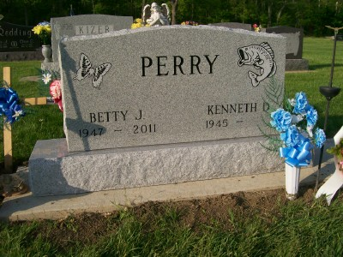
Photo by Scott Shoup
Betty Jean Perry, 64, of Nottingham Township in Wells County, passed away at 6 a.m. Sunday, May 8, 2011, at her Keystone residence.
Mrs. Perry was a volunteer for the C?? Community School and attended the Sonlight Wesleyan Church in Bluffton. She was a driver for Headstart and had worked at the Dutch Mill in Bluffton. She enjoyed bowling, camping and word puzzles.
She attended schools at Kendallville.
She was born May 2, 1947 in Kentucky, to Charlie Bailey and Ella (Toy) Bailey Egly. Her mother survives in Bluffton. She married Kenny Perry, Sr., Nov. 9, 1963 in Bluffton; her husband survives in Keystone.
Surviving in addition to her mother and husband, are a son, Kenny Perry, Jr. of Montpelier; two daughters, Patty Daugherty of Ossian and Jane Perry of Montpelier; eight grandchildren and one great-grandchild; six brothers, Larry Bailey, John Bailey, Tom Bailey, Terry Egly, Jerry Egly, and Randy Egly, all of Wells County, and a sister, Carolyn Egly of Wells County.
She was preceded in death by her father, Charlie Bailey; two brothers, Chucky Bailey and Carl Ray Bailey; and a granddaughter, Brandi Perry.
Calling will be from 2 to 8 p.m. Wednesday, May 11, at the Walker and Glancy Funeral Home, 109 W. Windsor Sr., Montpelier. A service to commemorate her life will be held at 10 a.m. Thursday, May 12, at the funeral home, with Pastor Wayne Ball officiating. Interment will be at the Six Mile Cemetery in Bluffton.
News Banner, Wells County, Indiana
May 10, 2011

