Helen Jeanetta Meyer
July 1, 1922 – September 6, 1936

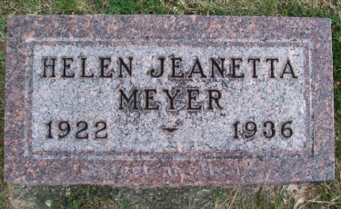
Photo by Scott Shoup

FUNERAL FOR HELEN MEYER HELD YESTERDAY

Funeral services for Helen Jean(?) Meyer, aged 14, of Vera Cruz, was held yesterday afternoon at the (?) Mennonite church. Miss Meyer was the daughter of Mr. and Mrs. Joseph Meyer, having passed away at the Wells County Hospital Sunday night. Death was caused by blood-poisoning following a mas(?) operation.
Surviving are the parents and brothers, Harold, Kenneth and Don(?) all at home. The services were in charge of (?) N.J. Schmucker, assisted by Rev. H. Meckstroth, of Vera Cruz.
Interment took place at the Six Mile cemetery on the angling road to Bluffton.

Adams County (IN) Historical Museum
1936 Scrapbook, image 102
Thursday, September 10, 1936

