Hugh French
May 21, 1888 – May 18, 1957

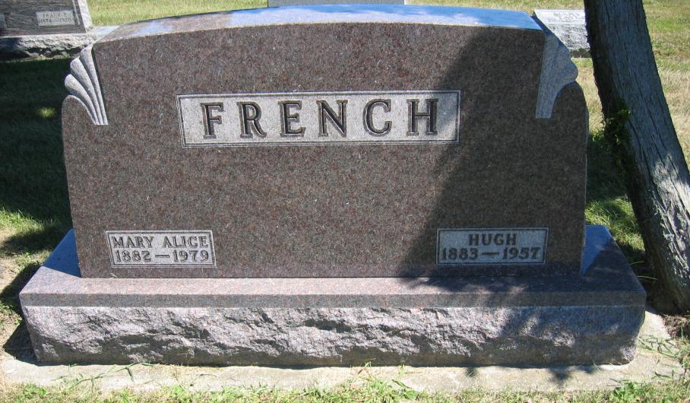
Photo by Tombstoner & Family

Hugh French Dies Suddenly Saturday
Hugh French, 68, Wells County farmer residing on Geneva Route l, died unexpectedly at 2:30 p.m. Saturday while driving his car in Montpelier.
Surviving are his wife, Mary; a daughter, Mrs. Clifford Settle of Petroleum; a nephew, Delorn Pease, reared in the French home; a sister, Mrs. J. Edward Miller of near Bluffton, and three brothers, Noah and Harry of Fort Wayne, and Roy of Rockford. O.
Services will be held at 2 p.m. Wednesday at the First Baptist Church in Bluffton, with burial in Six Mile Cemetery. Friends may call at the Jahn-Goodwin-Reed Funeral Home in Bluffton until noon Wednesday.
Decatur Daily Democrat, Adams County, Indiana
Monday, May 20, 1957

**
FRENCH, Hugh, 68, of Wells County died Saturday (May 18 - heart attack). Survived by widow, Mary; daughter, Mrs. Clifford Settle; sister, Mrs. Edward Moller and 3 brothers, Noah, Harry and Roy. First Baptist Church services in Bluffton.

Montpelier Herald, Blackford County, Indiana
Thursday, May 23, 1957, p.4, Col. 5

