Francis Marion French
August 1854 – January 30, 1924

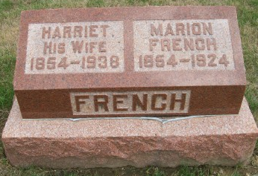
Photo by Scott Shoup

LINN GROVE RESIDENT FOUND DEAD IN LANE
Francis Marion French Accidentally Shoots Himself After Crawling Over Fence

Bluffton, Ind., Jan. 31. - Francis Marion French, 69, of Linn Grove, was found dead in a lane sixty rods from his home last night. He had accidently killed himself with an old-fashioned, muzzle-loading rifle, the bullet entering the body just below the heart.
His wife said that he had gone to the woods on his farm to cut hickory saplings to be used in smoking meat, and took along the gun with the expectation of killing an owl which had been taking chickens. Evidence at the scene of the tragic death indicated that he had thrown the ax and some sapling cuttings over the fence ahead of him and, after crawling over, was dragging the gun toward him when the hammer was caught on the fence and caused the gun to be discharged. The coroner of Adams County pronounced death due to accident.
Funeral services will likely be held Sunday afternoon at Six Mile Church.

The Star Press, Muncie, Indiana
Friday, February 1, 1924

**
Indiana, U.S., Marriage Index, 1800-1941
Name Francis French
Marriage Date 3 Sep 1876
Marriage Place Wells, Indiana, USA
Spouse Name Harriet Studabaker

**
Francis Marion French from tree Davis Family Tree
Birth Aug 1854 Indiana, USA
Marriage 3 Sep 1876 Wells, Indiana, USA
Residence 1920 Adams, Indiana, USA
Death 30 Jan 1924 Adams, Indiana, USA
Father Lot French (1813-1891)
Mother Mary Durst (1819-1907)
Spouse Harriet Studebaker (1854-1938)
69279 People 17 Records 17 Sources

