Mary E. (Hedges) Erhart
May 29, 1909 – October 22, 1992

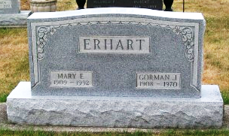
Photo by Scott Shoup

Mrs. Gorman (Mary) Erhart Dies; Rites to be Saturday
Widow of Gorman Erhart, Mrs. Mary E. Erhart, 83, of 1008 Ranch Rd., died at 12:39 p.m. Thursday at Wells Community Hospital following an illness of one day. Death was due to a stroke.
Born May 29, 1909 in Vermillion Co., Ill., she was a daughter of Arthur C. and Effa Smith Hedges. Her marriage to Mr. Erhart, who died in September 1971, took place Dec. 31, 1940 in Wells County.
Mrs. Erhart, a resident of Wells County since 1971, was a member of St. Luke's United Church of Christ. She and her late husband had been engaged in farming in French Twp., Adams County.
Surviving are a foster daughter, Mrs. Fred (Maxine) May of Kent, Wash.; two sisters, Mrs. Mark (Eunice) Athan and Mrs. Harold (Ruth) Bowman, both of rural Bluffton, and several nieces and nephews.
Friends may call from 1 to 9 p.m. today at Thoma-Rich Funeral Home.
Services will be at 10:30 a.m. Saturday at St. Luke's United Church of Christ, Rev. Jerry Flueckiger officiating and burial will be in the Six Mile Cemetery.
A preferred form of memorial is a gift to St. Luke's United Church of Christ.
Unknown newspaper clipping
Friday, October 23, 1992

