Sarah Ann (Edington) Crist
July 21, 1851 – March 11, 1908

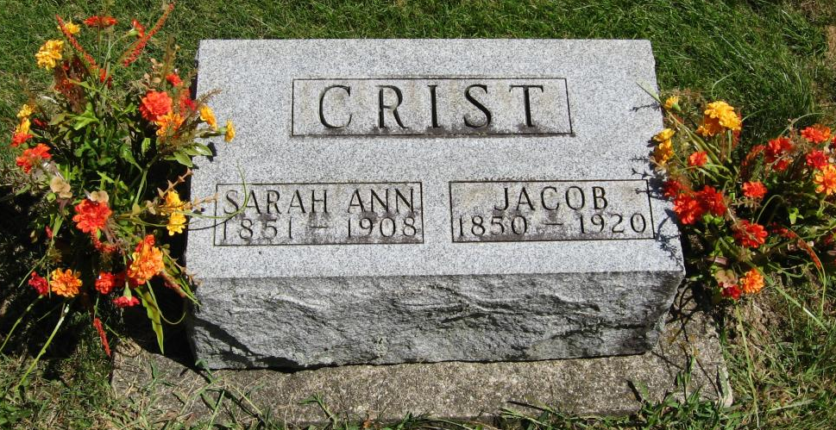
Photo by Tombstoner & Family

MRS. JACOB CRIST IS DEAD.
Lived in Wells County-Had Relatives Here.
Mrs. Jacob Crist passed away at 9:45 o'clock Wednesday evening at her home on Clark Avenue after a sickness of seven months duration, which was the result of cancer of the breast. Mrs. Crist had endured her long sufferings with that Christian fortitude which marked her life, but for several weeks no hope had been given for her recovery.
The funeral will be held at the Six Mile Christian Church Saturday forenoon, the funeral cortege leaving the residence at ten o’clock. The funeral services will be in charge of the Rev. J. J. Markley, of Murray.
Burial will occur in the Six Mile Cemetery.
Mrs. Crist was a daughter of John and Elizabeth Edington and was born on July 21, 1851, and at her death was in her fifty-seventh year. She was married on December 4, 1880, to Jacob Crist, and to this union were born seven children, of whom six are living. They are Mrs. Bessie Hoover, and Mrs. Cecil Sowards, Miss Flonie Crist and Cliffton, Ferdie and Charles Crist.
There are also surviving Mrs. Crist, three brothers and three sisters as follows: Ned Edington, of this city, Rufus, living in Ohio; James, of Decatur; Mrs. Kate Ulmer, of Poneto, Mrs. Susan Miller and Mrs. Ellen Weber, of Murray.
Mrs. Crist had spent the greater part of her life in Wells County and in addition to the many relatives, a wide circle of friends to mourn her death.
Decatur Daily Democrat, Adams County, Indiana
Friday, March 13, 1908

