Rebecca (Brown) Craig
July 9, 1843 – July 2, 1920

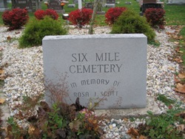
Photo by Barbara Baker Anderson

Indiana, U.S., Death Certificates, 1899-2011

Name: Rebecca A. Craig
[Rebecca A. Brown]
Gender: Female
Race: White
Age: 76y 11m 23d
Marital status: Widow
Birth Date: 9 Jul 1843
Birth Place: Wells Co, Ind.
Death Date: 2 Jul 1920
Death Place: Bluffton, Wells, Indiana, USA
Father: John Brown
Mother: Sarah Addison
Spouse: Harrison Craig
Informant: Ad. Craig
Burial: Six Mile July 4, 1920

