Mary Dell (Krummen) Cochran
December 29, 1921 – October 20, 2005

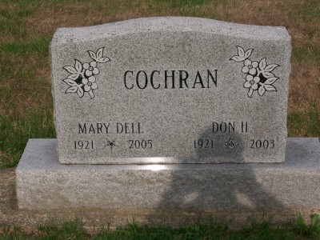
Photo by Scott Shoup

Mary Della "Dell" Cochran, 83, of Decatur died Thursday, Oct. 20 at Woodcrest Nursing Home.
Born Dec. 29, 1921 in Loretta, Ky., to Alfred and Nellie Captain Krummen, her marriage on Feb. 7, 1940 was to Don H. Cochran, who died Sept. 8, 2003.
A homemaker, she was a member of St. Mark's United Methodist Church and the UMC Builders Sunday School Class, Shalom Circle and Crescent Chapter 48 of the Order of Eastern Star.
Surviving are a son, Don Mark Cochran of Simpsonville, S.C., a daughter, Mrs. Sheldon (Elaine) Light of Fort Wayne; four grandchildren and three great grandchildren.
She was preceded in death by two brothers, Charles and Arlin Krummen and a sister, Vera Millikan.
Services will be held at 10 a.m. Monday at Haggard & Sefton Funeral Home in Decatur with Rev. Jeff Taylor and Rev. Fuhrman Miller officiating. Burial will be in Six Mile Cemetery at Bluffton. Calling at the funeral home will be Sunday from 12 to 5 p.m. Preferred memorials are to St. Mark's United Methodist Church or the Alzheimer's Foundation.

Bluffton News-Banner, Wells County, Indiana
Saturday, Oct. 22, 2005

