Ida May (Captain) Chalfant
June 1, 1889 – August 24, 1974

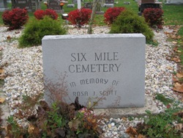
Photo by Barbara Baker Anderson

Mrs. Ida May Chalfant, 85, of 209 ½ West Wabash Street was found dead at her home by a granddaughter.
A native and lifelong resident of Wells County, she was born June 1,
1889, a daughter of John W. and Marianne Sovine Captain. Her marriage to Brent Chalfant, who died September 19, 1942, took place June 30, 1906 in Wells County.
Surviving are two daughters, Mrs. Eva Reynolds of Willshire, Ohio and Mrs. Ivan (Lois) Hammond of Albion, Route 4; one brother, John Captain of Kalamazoo, Michigan; nine grandchildren and 17 great-grandchildren.
Services will be Tuesday at Goodwin Memorial Chapel with Rev. Max Andrew officiating; burial in Six Mile Cemetery.
Bluffton News-Banner, Wells County, Indiana
August 24, 1974

