Charles Henry Captain
January 4, 1880 – August 17, 1959

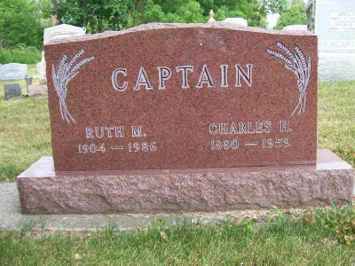
Photo by Scott Shoup

Indiana, Death Certificates, 1899-2011

Name: Charles H. Captain
Gender: Male
Race: White
Age: 79y 7m 13d
Marital status: Married
Birth Date: 4 Jan 1880
Birth Place: Wells Co Ind.
Death Date: 17 Aug 1959
Death Place: Bluffton, Wells, Indiana, USA
Father: John E Captain
Mother: Mary Ann Sovine
Informant: Chas. F. Captain, son
Burial: 8-19-1959 Six Mile

