Thomas Frank Brown
July 6, 1852 – February 18, 1922

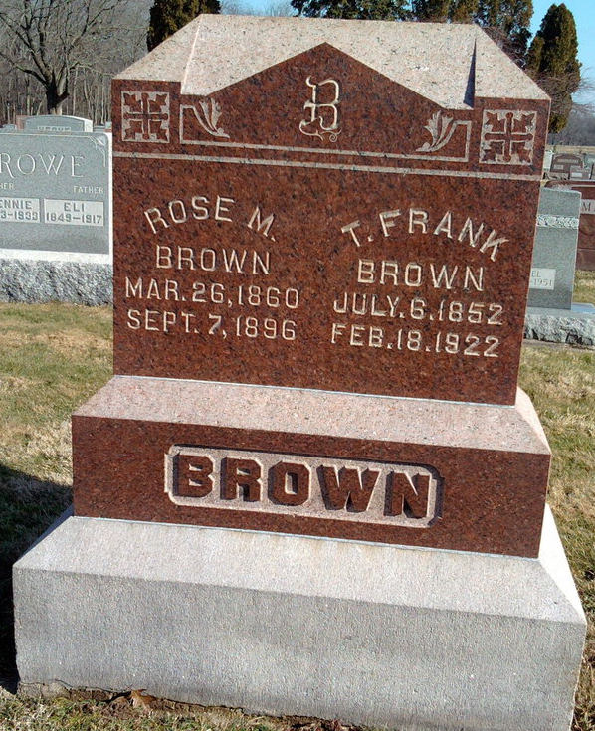
Photo by Thomas Liby

Indiana, U.S., Death Certificates, 1899-2011

Name: T. Frank Brown (indexed as J. Frank Brown)
Gender: Male
Race: White
Age: 69
Marital status: Widow
Birth Date: 6 Jul 1852
Birth Place: Ohio
Death Date: 18 Feb 1922, crushed by bull
Death Place: Chester, Wells, Indiana, USA
Father: Wm Brown
Mother: Harriett Johnson
Informant: Arthur Drum, Bluffton
Burial: Six Mile Cemetery 2/21/1922

