Solomon Brown
November 4, 1844 – March 1, 1936

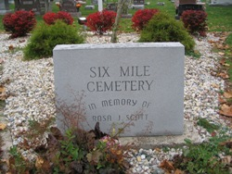
Photo by Barbara Baker Anderson

Indiana, U.S., Death Certificates, 1899-2011

Name: Soloman Brown
Gender: Male
Race: White
Age: 91y 3m 27d
Marital status: Widower
Birth Date: 4 Nov 1844
Birth Place: Lebanon PA
Death Date: 1 Mar 1936
Death Place: Bluffton, Wells, Indiana, USA
Father: David Brown
Mother: Sarah Mast
Spouse: Hannah Haiflich
Informant: Mrs. Wm. Travis, Bluffton
Burial: Six Mile Cem. 3-4-1936

